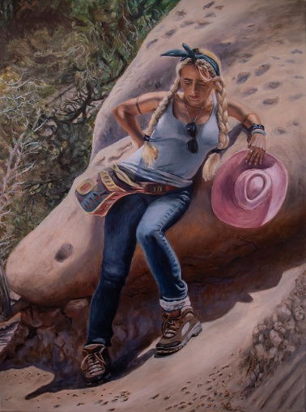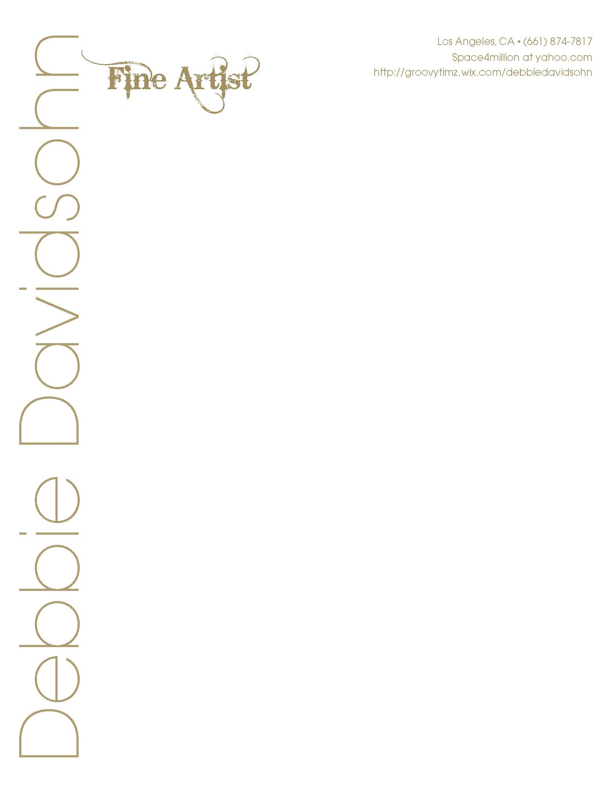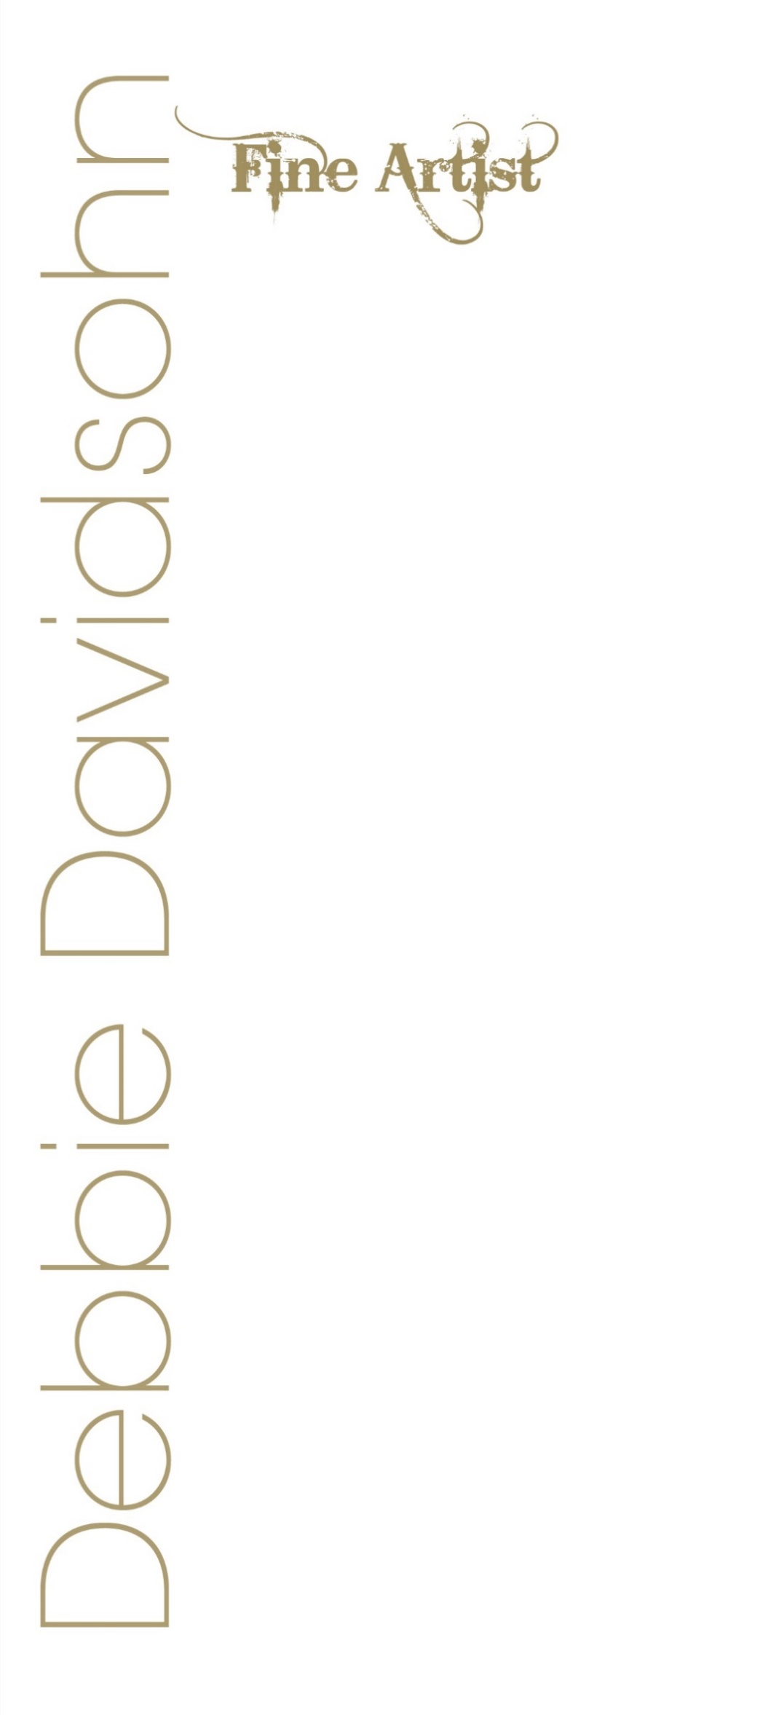

*“Self-Portrait, Punchbowl”*, Oil on linen, 36x24, 2021

Objectives

My objective is to exhibit my art in galleries and museums worldwide, create fine

art and public art, and to sell my art to collectors, art patrons, and art investors. I

teach fine art painting and drawing.

Education

**Academy of Art University, San Francisco**

MFA Fine Art (Painting & Drawing)

**California State Northridge University**

BA Studio Art / Minor English Lit/Creative Writing – Studio Art, Public Art, Illustration

National Society of Leadership and Success Honors Society

**Antelope Valley College**

2014

AA, Liberal Arts & Sciences, Arts and Humanities - Summa cum Laude Honors

**Cameo School of Fashion**

Certificate in Fashion Design

**Los Angeles City College**

Liberal Arts degree program

Exhibitions

*Generations Juried Art Exhibition*

Palmdale Playhouse, Palmdale, Ca.

2023

*Amalgam*- 2021 Friends of the Gallery Exhibition

AVC Gallery, Antelope Valley, Ca.

2021

Borders Boundaries Limits / Friends of the Gallery

AVC Gallery, Lancaster, CA.

2019

C.R.E.A.T.E

Desert Vineyard Christian Fellowship, Antelope Valley, California

2019

Viva El Arte

Downey Arts Coalition

Downey Civic Theatre, Downey, California

2018

Pen and Ink

Union Street Gallery, Chicago Heights, Illinois

2018

The Dream is the Truth

Buena Park City Council Chamber, Buena Park, CA.

2017

Honor Recognition Award from California Legislature

The Dream is the Truth – Art Inspired by Frida Kahlo

Buena Park City Council Chamber, Buena Park, CA.

2017

CEDARFEST – 32nd Annual Juried Arts Festival

2017

Lancaster Museum of Art and History: Cedar, Lancaster, CA.

**ALL THOSE WHO ANSWER – Artists Who Did Service for America**

2017

Antelope Valley Art Gallery, Lancaster, California

ATMOSPHERE

**Friends of the Gallery**

2016

Antelope Valley Art Gallery, Lancaster, California

**100 YEAR OF WOMEN IN GOVERNMENT EXHIBITION**

Sponsored by State Representative, Barbara Wheeler

2016

Dole Mansion & Art Gallery/Lakeside Legacy Foundation, Crystal Lake, Illinois

**MIGRATION 61**

2016-2017

Busboys and Poets, Washington, D.C.

**Art for the Soul / Chabad.org**

2016 – Perpetual

Art series added to permanent gallery collection

**PLAY**

2016

Los Angeles Municipal Art Gallery, Los Angeles, California

**BEACON/Friends of the Gallery**

2015

Antelope Valley Art Gallery, Lancaster, California

**AV Gallery – Four Varied Group Gallery Events**

**Friends of the Gallery**

2012 – 2014

Antelope Valley, Lancaster, California

**The Liberty Dog Store**

Product Design, Artist

2007-2016

Los Angeles – International

**CTFD/DANCERS MARKETPLACE**

1999

Los Angeles County Museum of Art, Los Angeles, California

**Double Dragon**

Fantasy set design – Film Production

**Rutelli Designs**

Interior design and private patrons of wooden furniture artwork

**Music Videos**

12 music videos – Costume Art, Set Design Art, Sculpture,

Performance Art, Directing, Producing, Filmmaking

Public Broadcasts, Hollywood, California

*Won Golden Star Halo Award from So. Ca. Motion Picture Council

**Costume Designs for Major Pop/Rock Stars (Celebrities)**

**Avant Garde art costumes for Stage Shows, Music Videos, Female Music Band, Sun Goddess**

Painted large mural backdrops, sold art and set up art displays, and performed in fundraising events

Verona & Chiodo Gardens

Creation of Large Koi Pond & Waterfall, Building Custom Benches, & Lighted Gazebo over Benches

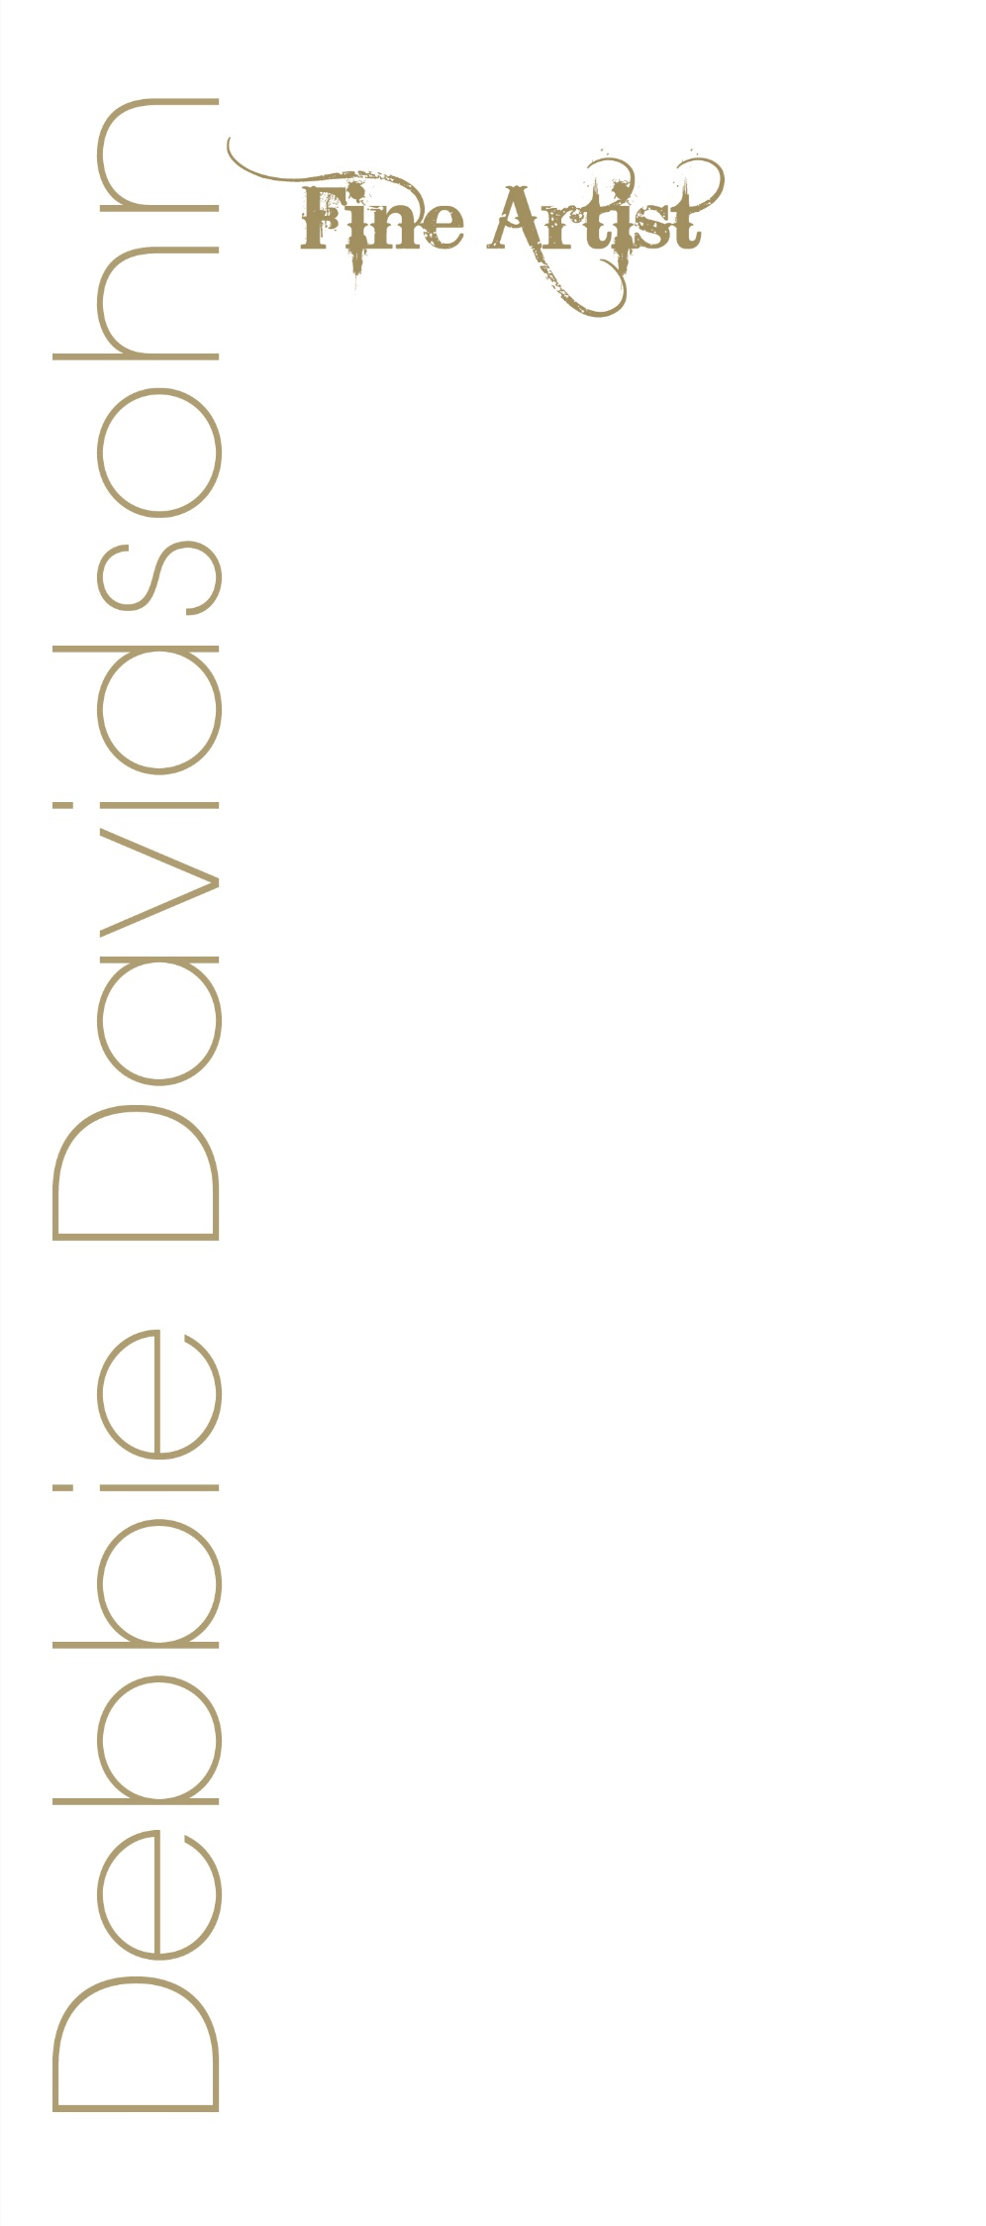

Collections

Private Art Collection, U.K.

Private Collection, U.K.

Private Collection, U.S.A.

Awards and Achievements

Honor Recognition Award from California Legislature

The Dream is the Truth

Buena Park City Council Chamber, Buena Park, CA.

2017

**Golden Star Halo Awards – Three Separate Awards**

(Director, Actress, Singer, Dancer, Associate Producer)

Southern California Motion Picture Council

1989, 1991

**Hometown Humanitarian Award – Honor’s Award from Alpha Iota**

May 2011

**Permanent Membership to Alpha Gamma Sigma-2014**

Team Iron Man – Outstanding Service Award-2014

**Dean’s Honor Lists**

Included on Dean’s Honor Lists every semester at Antelope Valley College and at CSUN since 2011 – 2016

President’s Honor Lists

A.V.C. – 2011-2014

## Dean’s Honor Roll at CSUN

2014-2017

National Society for Leadership & Success

Honor’s Society Member

Volunteer Work

**Children’s World Peace Foundation**

Political strategy, communications, fundraising, and event planning, int’l human relations

**The Pepper Foundation, Studio City, Ca.**

Rescues dogs and cats, fundraising, fostering needy,

geriatric, and abused pets – Make art and design for non-profit

**Department of Justice**

Making blankets for children, victims of rape

**Rose Breast Cancer Society**

Painted large mural backdrops, sold art and set up art displays, and performed in fundraising events

Affiliations

The American Artist’s Professional League, Inc.

Painting Guild, CSUN

**Americans for the Arts/ Arts Action Fund**

Political advocacy for arts in education and advancing the arts in America

**Member of AVC Art Gallery**

Friends of the gallery member

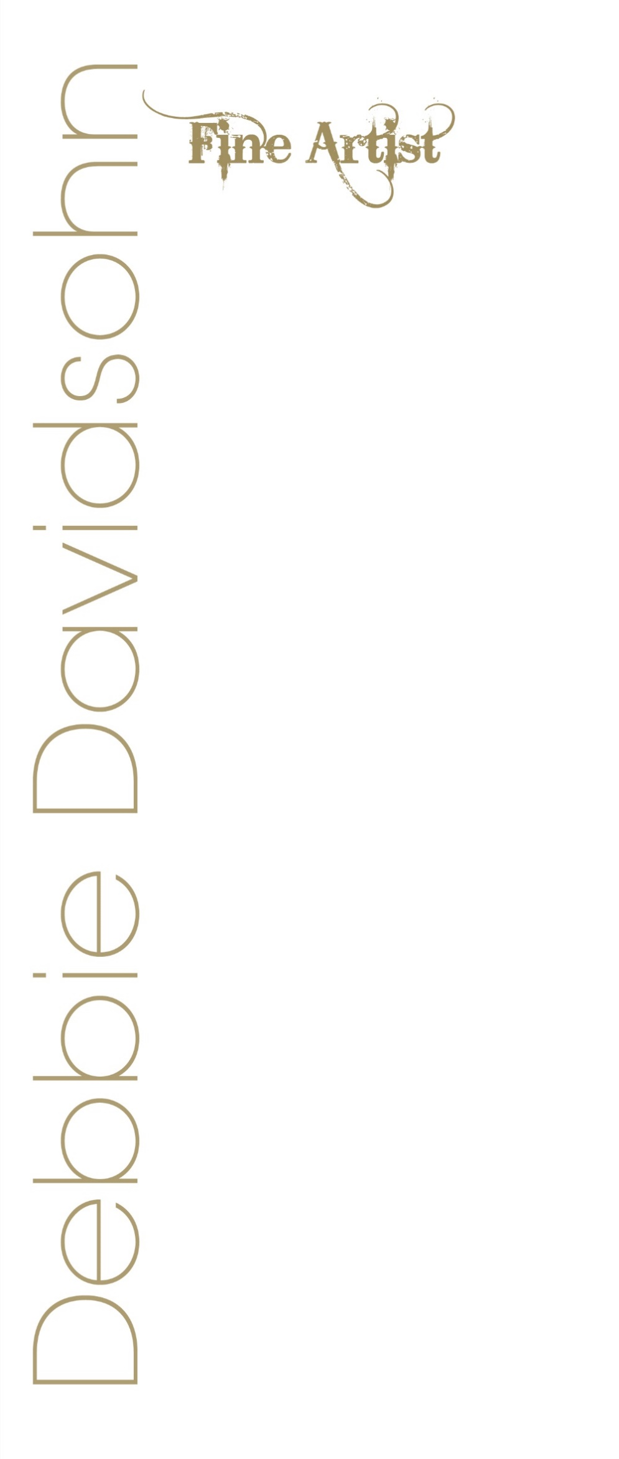

skills

Art, drawing, Photoshop, painting, oils and acrylics, watercolor, figure drawing, mixed media, sculpture, embroidery,

public art, installation, composition, organization, leadership, art directing, planning, interior design, filmmaking,

producing, directing, comedy and humor, color photography, digital photography, black and white photography and

developing, concept art, packaging, and illustration. Studied choreography, dance, voice, acting, and music in private academies, colleges, and on scholarships.

## Teaching

DHS – County of Los Angeles

Art instruction for challenged adults and children

City of Los Angeles

Music, Dance, and Singing Instructor (tap, ballet, jazz, piano lessons)

Produce, Choreograph, & stage live performances for the public

(Ages 3 – adult)

Private Voice, Dance, & Music Instructor

## Publication

CAPTURED

AMERICA: ALREADY GREAT

6th Annual 2016-17 Student Research Journal: Print & Multi-Media Edition

Two Artworks: *Women’s Rights are Human Rights* and *A Little Equality Goes a Long Way*

Article: *Boris Max’s Courtroom Speech: Native Son, The Vision of Richard Wright*

WAVES 2022 – A Room of Her Own Foundation Org.

Artwork “Amber” Published for “Your Work Matters” May 27, 2022

Personal Interests

I am interested in travel, museums, art, dance, film, cultures comedy and improvisation, music, ethics, galleries, shows, health, sports, dance arts, literature, weight lifting and gym sports, friends and family, and achieving great success.

Other Studies in the Arts

Film Studies at Av College, Theatre Studies at LACC & AV College, Dance Studies & Choreography at Glendale College, and tens of other private academies, Voice studies and voice scholarship in opera and other styles, Photography Studies, Acting studies at Glendale College, AV College, Sunset Gower Studios.