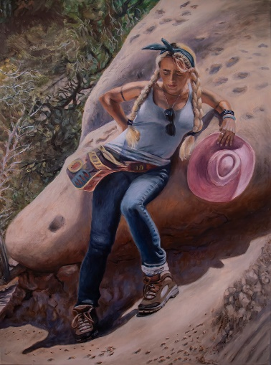
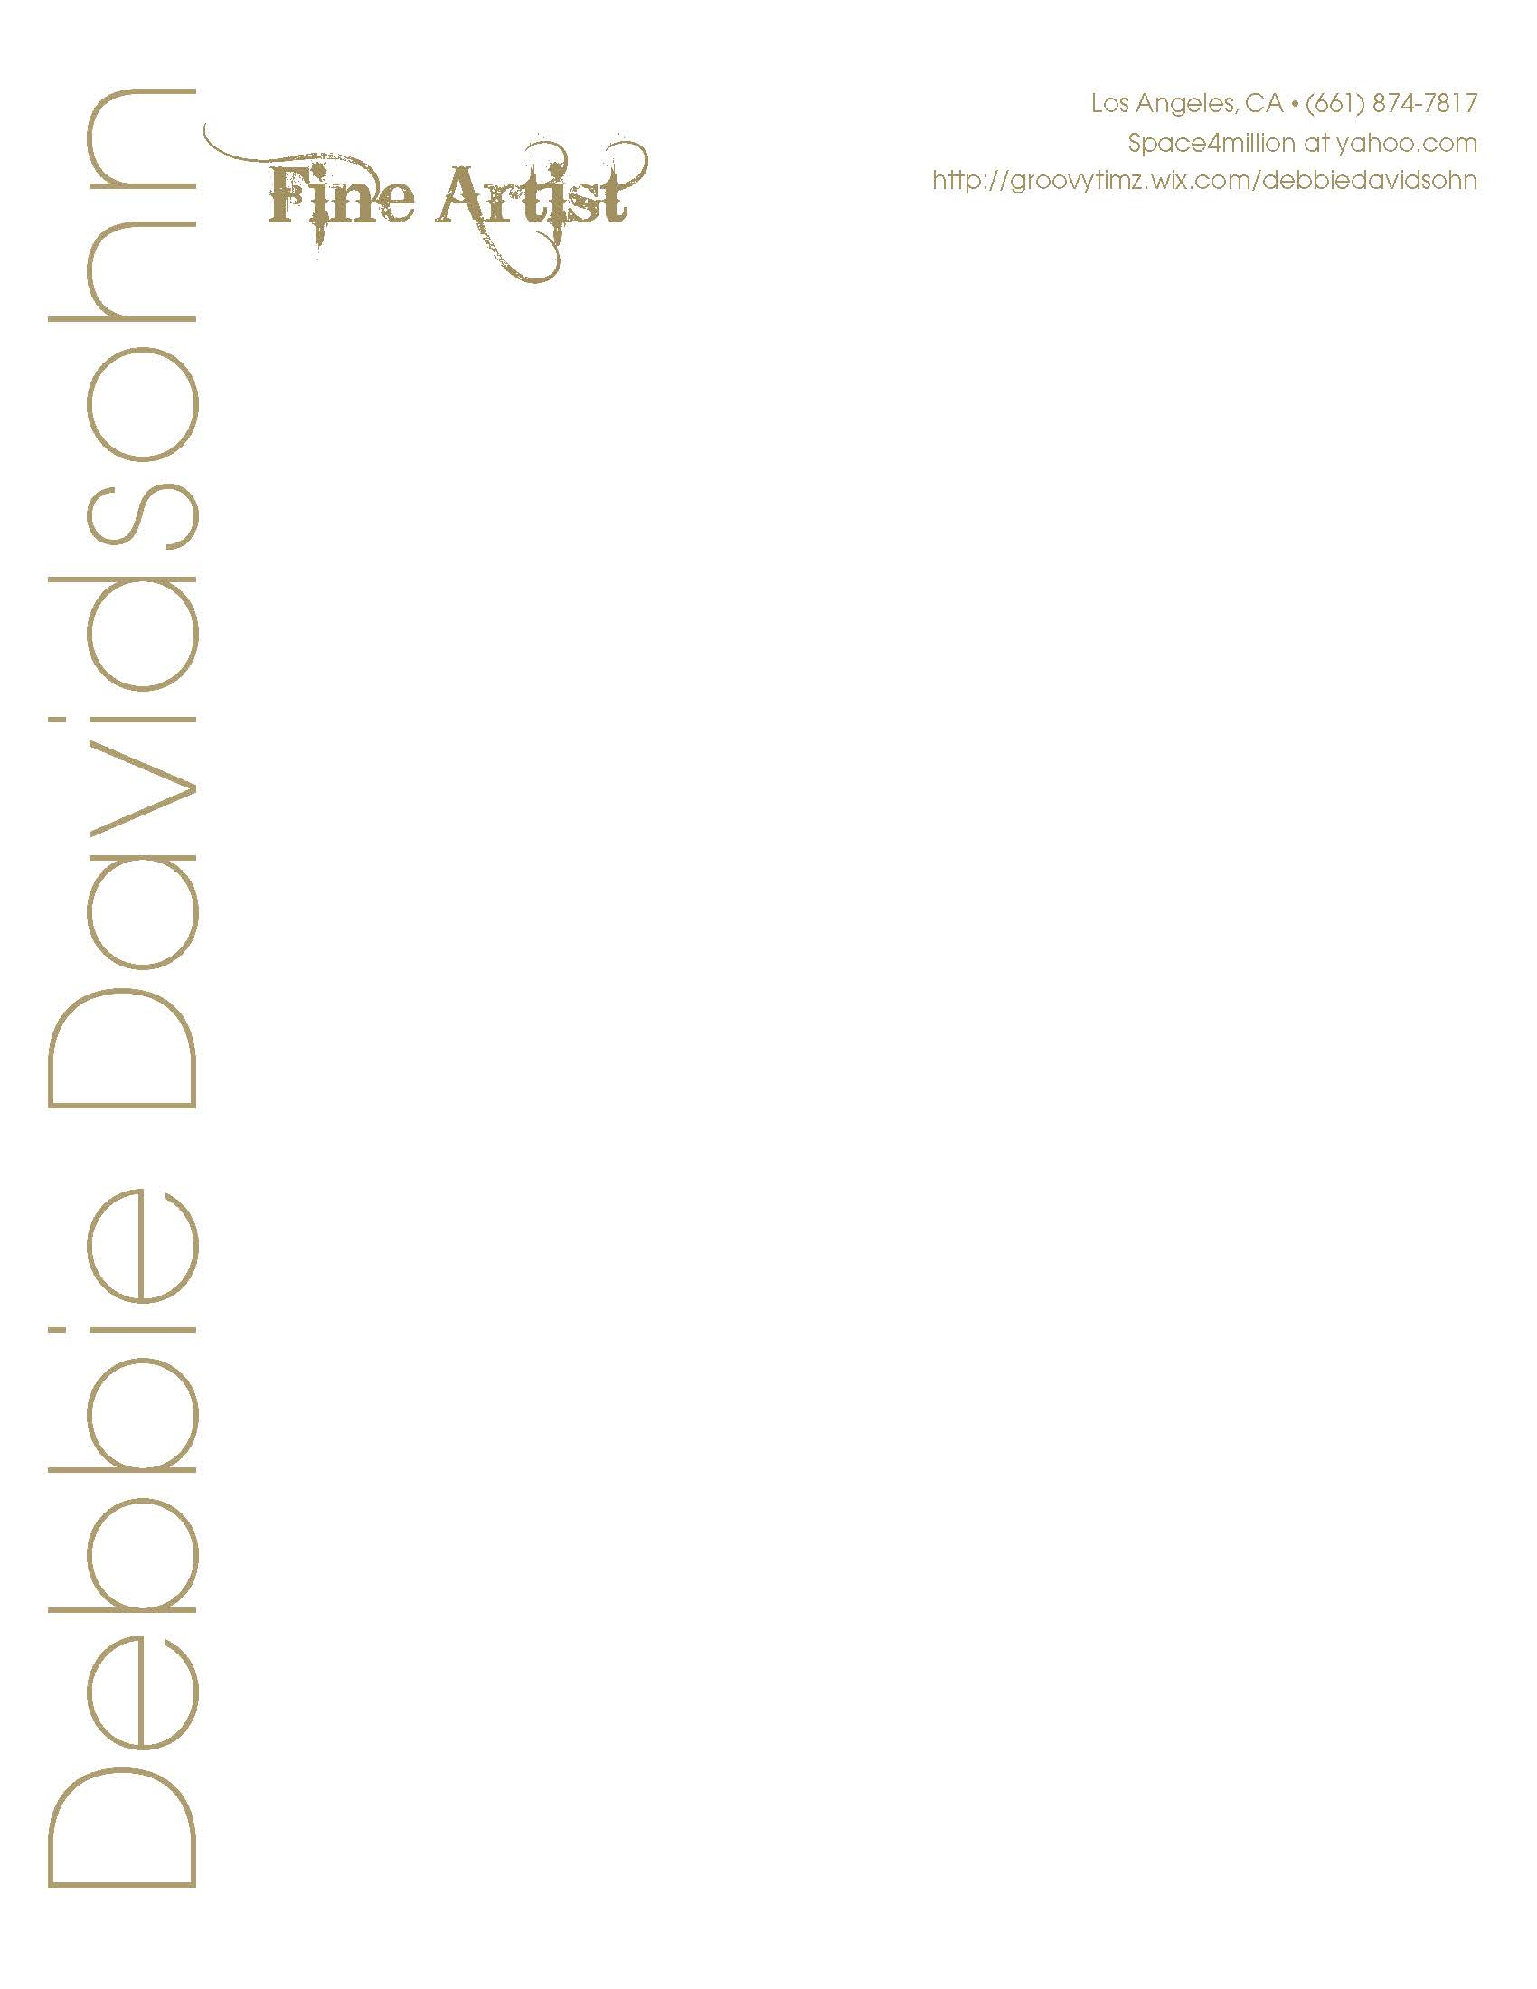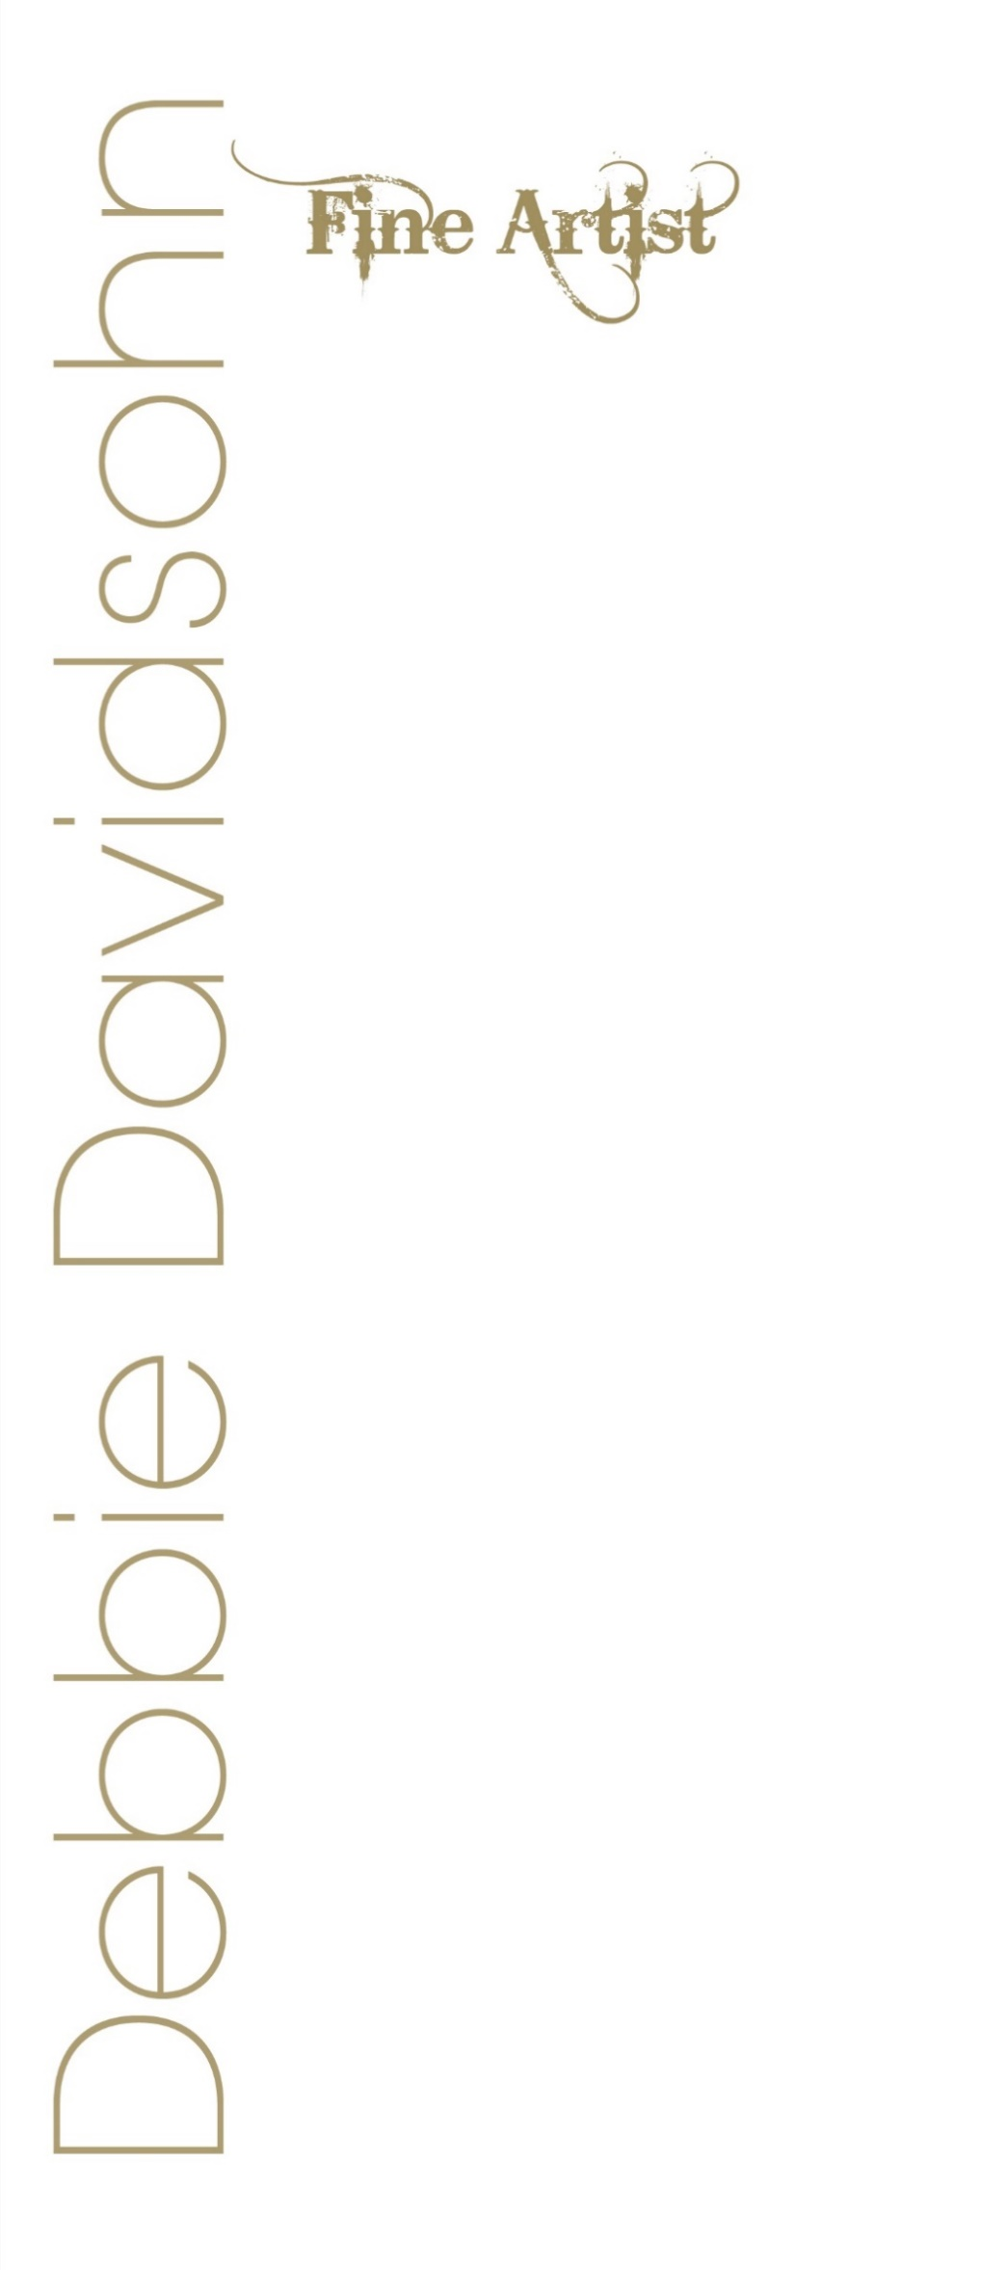
“Self-Portrait, Punchbowl”, Oil on linen, 36x24, 2021
Objectives
My objective is to exhibit my art in galleries and museums worldwide, create fine
art and public art, and to sell my art to collectors, art patrons, and art investors. I
teach fine art painting and drawing.

Education
Academy of Art University, San Francisco
MFA Fine Art (Painting & Drawing)
California State Northridge University
BA Studio Art / Minor English Lit/Creative Writing – Studio Art, Public Art, Illustration
National Society of Leadership and Success Honors Society
Antelope Valley College
2014
AA, Liberal Arts & Sciences, Arts and Humanities - Summa cum Laude Honors
Cameo School of Fashion
Certificate in Fashion Design
Los Angeles City College
Liberal Arts degree program

Exhibitions
MOAH – CEDAR Juried Art Show 2025
40th Anniversary
3rd Place Winner - Generations Juried Art Exhibition
Palmdale, Ca.
2024
Generations Juried Art Exhibition
Palmdale Playhouse, Palmdale, Ca.
2023
Amalgam- 2021 Friends of the Gallery Exhibition
AVC Gallery, Antelope Valley, Ca.
2021
Borders Boundaries Limits / Friends of the Gallery
AVC Gallery, Lancaster, CA.
2019
C.R.E.A.T.E
Desert Vineyard Christian Fellowship, Antelope Valley, California
2019
Viva El Arte
Downey Arts Coalition
Downey Civic Theatre, Downey, California
2018
Pen and Ink
Union Street Gallery, Chicago Heights, Illinois
2018
The Dream is the Truth
Buena Park City Council Chamber, Buena Park, CA.
2017
Honor Recognition Award from California Legislature
The Dream is the Truth – Art Inspired by Frida Kahlo
Buena Park City Council Chamber, Buena Park, CA.
2017
Lancaster Museum of Art and History: Cedar, Lancaster, CA.
CEDARFEST – 32nd Annual Juried Arts Festival
2017
Lancaster Museum of Art and History: Cedar, Lancaster, CA.
ALL THOSE WHO ANSWER – Artists Who Did Service for America
2017
Antelope Valley Art Gallery, Lancaster, California
ATMOSPHERE
Friends of the Gallery
2016
Antelope Valley Art Gallery, Lancaster, California
100 YEAR OF WOMEN IN GOVERNMENT EXHIBITION
Sponsored by State Representative, Barbara Wheeler
2016
Dole Mansion & Art Gallery/Lakeside Legacy Foundation, Crystal Lake, Illinois
MIGRATION 61
2016-2017
Busboys and Poets, Washington, D.C.
Art for the Soul / Chabad.org
2016 – Perpetual
Art series added to permanent gallery collection
PLAY
2016
Los Angeles Municipal Art Gallery, Los Angeles, California
BEACON/Friends of the Gallery
2015
Antelope Valley Art Gallery, Lancaster, California
AV Gallery – Four Varied Group Gallery Events
Friends of the Gallery
2012 – 2014
Antelope Valley, Lancaster, California
The Liberty Dog Store
Product Design, Artist
2007-2016
Los Angeles – International
CTFD/DANCERS MARKETPLACE
1999
Los Angeles County Museum of Art, Los Angeles, California
Double Dragon
Fantasy set design – Film Production
Rutelli Designs
Interior design and private patrons of wooden furniture artwork
Music Videos
12 music videos – Costume Art, Set Design Art, Sculpture,
Performance Art, Directing, Producing, Filmmaking
Public Broadcasts, Hollywood, California
*Won 3 Golden Star Halo Awards from So. Ca. Motion Picture Council
Costume Designs for Major Pop/Rock Stars (Celebrities)
Avant Garde art costumes for Stage Shows, Music Videos, Female Music Band, Sun Goddess
Painted large mural backdrops, sold art and set up art displays, and performed in fundraising events
Verona & Chiodo Gardens
Creation of Large Koi Pond & Waterfall, Building Custom Benches, & Lighted Gazebo over Benches

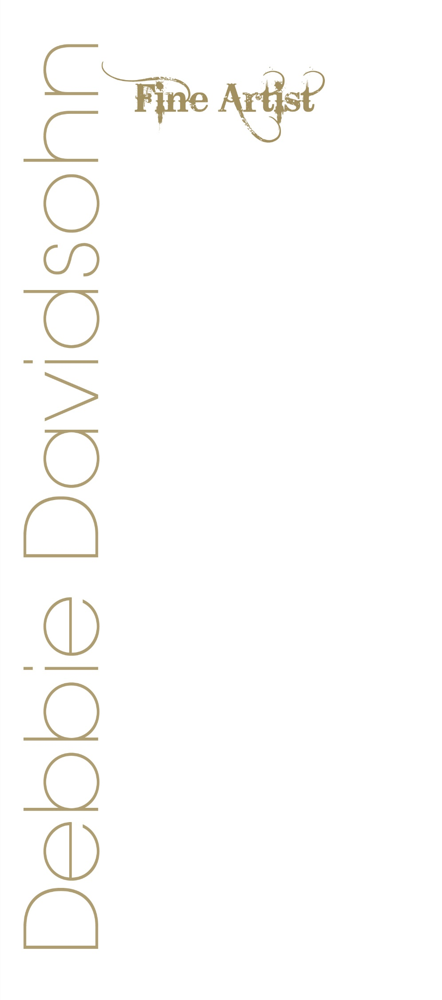
Collections
Private Art Collection, U.K.
Private Collection, U.K.
Private Collection, U.S.A.

Awards and Achievements
3rd Place Recognition from the City of Palmdale for painting, Bleau
Generations Juried Art Exhibition, 2024
Honor Recognition Award from California Legislature
The Dream is the Truth
Buena Park City Council Chamber, Buena Park, CA.
2017
Golden Star Halo Awards – Three Separate Awards
(Director, Actress, Singer, Dancer, Associate Producer)
Southern California Motion Picture Council
1989, 1991
Hometown Humanitarian Award – Honor’s Award from Alpha Iota
May 2011
Permanent Membership to Alpha Gamma Sigma-2014
Team Iron Man – Outstanding Service Award-2014
Dean’s Honor Lists
Included on Dean’s Honor Lists every semester at Antelope Valley College and at CSUN since 2011 – 2016
President’s Honor Lists
A.V.C. – 2011-2014

Dean’s Honor Roll at CSUN
2014-2017
National Society for Leadership & Success
Honor’s Society Member
Volunteer Work
Children’s World Peace Foundation
Political strategy, communications, fundraising, and event planning, int’l human relations
The Pepper Foundation, Studio City, Ca.
Rescues dogs and cats, fundraising, fostering needy,
geriatric, and abused pets – Make art and design for non-profit
Department of Justice
Making blankets for children, victims of rape
Rose Breast Cancer Society
Painted large mural backdrops, sold art and set up art displays, and performed in fundraising events

Affiliations
The American Artist’s Professional League, Inc.
Painting Guild, CSUN
Americans for the Arts/ Arts Action Fund
Political advocacy for arts in education and advancing the arts in America
Member of AVC Art Gallery
Friends of the gallery member

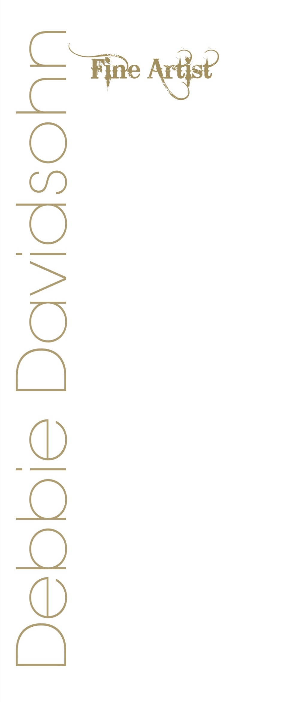
skills
Art, drawing, Photoshop, painting, oils and acrylics, watercolor, figure drawing, mixed media, sculpture, embroidery,
public art, installation, composition, organization, leadership, art directing, planning, interior design, filmmaking,
producing, directing, comedy and humor, color photography, digital photography, black and white photography and
developing, concept art, packaging, and illustration. Studied choreography, dance, voice, acting, and music in private academies, colleges, and on scholarships.

Teaching
DHS – County of Los Angeles
Art instruction for challenged adults and children
City of Los Angeles
Music, Dance, and Singing Instructor (tap, ballet, jazz, piano lessons)
Produce, Choreograph, & stage live performances for the public
(Ages 3 – adult)
Private Voice, Dance, & Music Instructor

Publication
CAPTURED
AMERICA: ALREADY GREAT
6th Annual 2016-17 Student Research Journal: Print & Multi-Media Edition
Two Artworks: Women’s Rights are Human Rights and A Little Equality Goes a Long Way
Article: Boris Max’s Courtroom Speech: Native Son, The Vision of Richard Wright
WAVES 2022 – A Room of Her Own Foundation Org.
Artwork “Amber” Published for “Your Work Matters” May 27, 2022
ARTIST’S PROFESSIONAL LEAGUE, GRAPEVINE PUBLICATION
2022
Personal Interests
I am interested in travel, museums, art, dance, film, cultures comedy and improvisation, music, ethics, galleries, shows, health, sports, dance arts, literature, weight lifting and gym sports, friends and family, and achieving great success.
Other Studies in the Arts
Film Studies at Av College, Theatre Studies at LACC & AV College, Dance Studies & Choreography at Glendale College, and tens of other private academies, Voice studies and voice scholarship in opera and other styles, Photography Studies, Acting studies at Glendale College, AV College, Sunset Gower Studios.

